Sales Data Analysis Forecasting
Cocoa and Plantain Farming: Project Report

Project Title: Sales Data Analysis Forecasting— Financial Performance and Forecasting
Objective: To analyze historical financial and operational performance of cocoa and plantain farming, and forecast future revenue, expenses, and profit to inform strategic decisions.
Tools: I used Power query in power bi for data cleaning and Power bi for Data Analysis and visualization. I also used Prophet; a forecasting model to predict financial performance for the next 5 years.

Dashboard 1: Performance Analysis
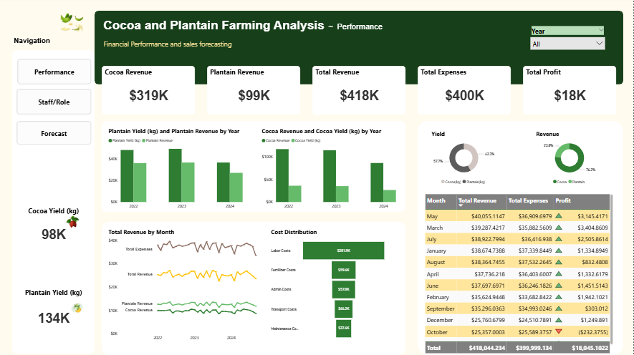

Key Insights:
Total revenue from 2022–2024 = $418K, with cocoa contributing $319K and plantain $99K (Cocoa = 76% of income, Plantain = 24%).
Total Expenses = $400K, leaving a slim profit of $18K.
October shows a net loss; possibly seasonal or operational inefficiency. .
Cocoa generates more value per kg than plantain despite slightly lower yield.
Labor ($123K) and Admin ($83K) are the largest cost drivers.
Recommendations:
Expand cocoa operations and improve plantain efficiency.
Reduce labor and admin costs via automation or workforce restructuring.
Investigate month-on-month loss patterns (e.g., October) for actionable insights.

Dashboard 2: Forecast Analysis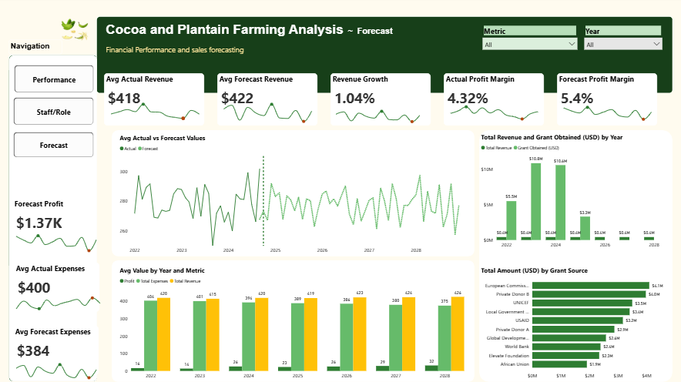

Key Insights:
Average Forecast Revenue ($422) is slightly higher than Average Actual Revenue ($418), showing 1.04% revenue growth, indicating modest sales or yield improvement.
Forecast Profit Margin (5.43%) is higher than Actual Profit Margin (4.32%), reflecting better anticipated cost control.
Forecast Profit ($1.37K) remains relatively low compared to Forecast Revenue ($25.17K), signaling tight profit margins.
Average Forecast Expense ($384) is slightly lower than Average Actual Expense ($400), indicating better cost control.
The Average Value for Actual (11.07% increase) and Forecast (3.61% increase) both trended up between January 2022 and December 2028.﻿
Across all 12 Month, Average Actual Revenue ranged from $409 to $431.﻿
Revenue and expenses show steady trends through 2024–2028, suggesting a stable business outlook.
Grants significantly boosted revenue in 2022–2024, e.g. $10.6M in 2023 and 2024. - Top sources: European Commission ($4.1M), Private Donors A ($3.6M), Local Government, UNICEF.

Recommendations:
Optimize operations further to improve margins.
Reduce reliance on grant funding — grants inflate revenue temporarily but aren’t sustainable. Explore more sustainable income streams.
Investigate scalable revenue strategies (e.g., product diversification, yield improvements).

Dashboard 3: Staff and Role Analysis
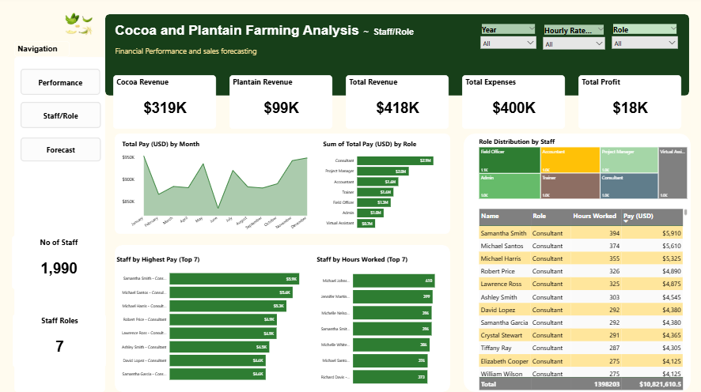

Key Insights:
Total Staff: 1,990 across 7 Roles.
Consultants dominate pay but work less except Samantha Smith who logged 394hrs (Top 4) and earned most ($5.9K).
Consultant & Project Manager roles cost over $2M collectively.
Field Officers and Accountants are the most populated roles.

Recommendations:
Reassess staff contributions vs cost — are high earners driving enough value?
Align expensive roles with revenue-generating periods.
Consider upskilling or tech investments to reduce dependency on top-cost roles.

Summary of Findings
Area | Insight | Recommendation
Forecast | Revenue and margins improving slightly | Sustain performance, cut costs
Grants | Large revenue booster (2022–2024) | Develop sustainable alternatives
Profitability | Still low (<6%) | Focus on cost efficiency
Yield | Cocoa > Plantain in value | Expand cocoa initiatives
Staff | High-cost roles dominate | Optimize staff ROI

Prepared by: Emediong Bassey Ekanem
Tool Used: Power BI + Prophet (Forecasting Model)
Date: July 2025

